Content Standard: (Gr. 1) 6A.1.k Count forward and backward starting with numbers other than one.
http://www.primarygames.co.uk/pg2/splat/splatsq100.html

Name__________________________________ Date__________

Jane is on block 3.

Part A: If she takes 5 more steps, on which block will she be?

______________________________________________________
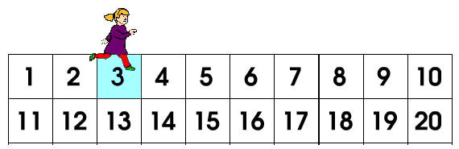

Part B: Use what you know about numbers or counting to explain why your answer is correct. Use words and/or pictures in your explanation.

- - - - - - - - - - - - - - - - - - - - - - - - - - - - - - - - - - - - - - - - - - - - - - - - - - - - - - - - - - - - - -
________________________________________________________________________

- - - - - - - - - - - - - - - - - - - - - - - - - - - - - - - - - - - - - - - - - - - - - - - - - - - - - - - - - - - - - -
________________________________________________________________________

- - - - - - - - - - - - - - - - - - - - - - - - - - - - - - - - - - - - - - - - - - - - - - - - - - - - - - - - - - - - - -
________________________________________________________________________

- - - - - - - - - - - - - - - - - - - - - - - - - - - - - - - - - - - - - - - - - - - - - - - - - - - - - - - - - - - - - -
________________________________________________________________________

