Content Standard: (Gr. 1, 2) 3B.1.a Measure length of objects and pictures of objects using a ruler or tape measure to the nearest inch, centimeter and foot.

http://www.funbrain.com/funbrain/cgi-bin/meas.cgi

Name__________________________________ Date__________

Kevin and Brianna measured their pencils. Both said that their pencils measured 7 inches but one of them was not correct.

PART A: Who did not measure the pencil correctly?
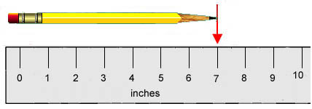

Kevin’s pencil

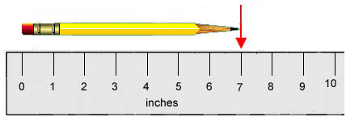

Brianna’s pencil
_________________________________________________

Part B: Use what you know about measurement to explain why your answer is correct. Use words and/or pictures in your explanation.
- - - - - - - - - - - - - - - - - - - - - - - - - - - - - - - - - - - - - - - - - - - - - - - - - - - - - - - - - - - - - -
________________________________________________________________________

- - - - - - - - - - - - - - - - - - - - - - - - - - - - - - - - - - - - - - - - - - - - - - - - - - - - - - - - - - - - - -
________________________________________________________________________

- - - - - - - - - - - - - - - - - - - - - - - - - - - - - - - - - - - - - - - - - - - - - - - - - - - - - - - - - - - - - -
________________________________________________________________________

