Content Standard: (Gr. 2) 3B.1.c Measure weights/mass of objects to the nearest pound and kilogram using a variety of scales.

http://atschool.eduweb.co.uk/toftwood/weight.html

Name__________________________________ Date__________

Jordan put a box on the scale.
Part A: How much does the box on the scale weigh?

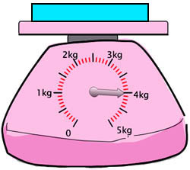
____________________

Past B: Use what you know about scales and numbers to explain why your answer is correct. Use words and/or pictures in your explanation.

- - - - - - - - - - - - - - - - - - - - - - - - - - - - - - - - - - - - - - - - - - - - - - - - - - - - - - - - - - - - - -
________________________________________________________________________

- - - - - - - - - - - - - - - - - - - - - - - - - - - - - - - - - - - - - - - - - - - - - - - - - - - - - - - - - - - - - -
________________________________________________________________________

- - - - - - - - - - - - - - - - - - - - - - - - - - - - - - - - - - - - - - - - - - - - - - - - - - - - - - - - - - - - - -
________________________________________________________________________

- - - - - - - - - - - - - - - - - - - - - - - - - - - - - - - - - - - - - - - - - - - - - - - - - - - - - - - - - - - - - -
________________________________________________________________________

