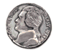
100 dollars 5 cents
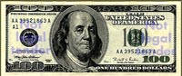
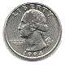
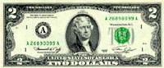

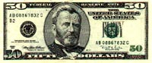
2 dollars 25 cents

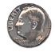
10 cents

50 dollars

Dear John,
Can you find out how much money is here? When you find out please tell me.

Your friend,
Lizzy

