Content Standard: (Gr. 4, 5) 2E.1.a Analyze a transformation
http://matti.usu.edu/nlvm/nav/frames_asid_207_g_1_t_3.html

Name__________________________________ Date__________

The picture shows the rocket in a transformed position.

PART A: What kind of transformation is shown below?

___________________________________________________

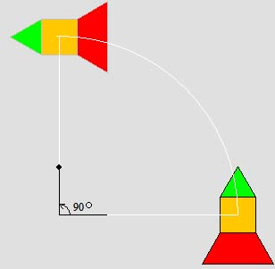

Part B: Use what you know about transformations to explain why your answer is correct. Use words and/or pictures in your explanation.

________________________________________________________________________

________________________________________________________________________

________________________________________________________________________

________________________________________________________________________

________________________________________________________________________

________________________________________________________________________

