Content Standard: (Gr. 3) 2E.2 Identify and describe symmetry in geometric figures or pictures

http://www.arcytech.org/java/patterns/patterns_j.shtml

Name__________________________________ Date__________

Alicia made these designs using Pattern Blocks.

Part A: Which of the following designs is an example of symmetry?

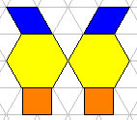  Figure A | 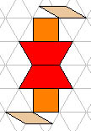  Figure B | 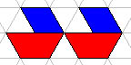  Figure C

_____________________________________________________

Part B: Use what you know about symmetry to explain why your answer is correct. Use words and/or pictures in your explanation.

________________________________________________________________________

________________________________________________________________________

________________________________________________________________________

________________________________________________________________________

________________________________________________________________________

________________________________________________________________________

