Content Standard: (Gr. 3, 4, 5) 5B.1.a Determine the probability of an event. Express the probability as a fraction.

http://www.interactive-resources.co.uk/mathspack2/pspin/pspin2.html

Name__________________________________ Date__________

You and a friend are playing a game using a spinner divided into 7 equal sections. You win if the spinner lands on a shaded section.

Part A: Is the game fair? Who has a more likely chance of winning? Express the probability for winning as a fraction.

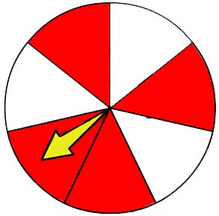
______________________

_______________________

Part B: Use what you know about probability to explain your answer. Use words and/or pictures in your explanation.

________________________________________________________________________

________________________________________________________________________

________________________________________________________________________

________________________________________________________________________

________________________________________________________________________

________________________________________________________________________

