Content Standard: (Gr. 3, 4,) 1A.1.a Represent and analyze numeric patterns using skip counting
http://ambleweb.digitalbrain.com/ambleweb/ambleweb/ambleweb/mentalmaths/numberlines.html

Name__________________________________ Date__________

Jane, Kevin and Kim are taking turns saying a number pattern.

Part A: What is the next number that Kim will say?

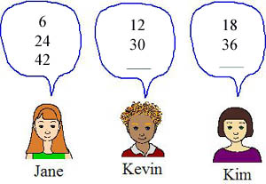

________________________________________________________________________

Part B: Use what you know about number patterns to explain why your answer is correct. Use words and/or pictures in your explanation.
________________________________________________________________________

________________________________________________________________________

________________________________________________________________________

________________________________________________________________________

________________________________________________________________________

________________________________________________________________________

