Content Standard: (Gr. 3) 6C.1.f; (Gr. 4) 6C.1.c ; (Gr. 5) 6C.1.a Represent multiplication and division basic facts using number sentences, pictures and drawings.

http://ambleweb.digitalbrain.com/ambleweb/ambleweb/ambleweb/mentalmaths/testtest.html

Name__________________________________ Date__________

Mr. Henry is building a brick wall.

Part A: How many bricks will the wall have when it is finished?

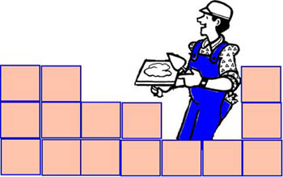

________________________________________________________________________

Part B: Use what you know about number operations to explain why your answer is correct. Use words and/or pictures in your explanation.

________________________________________________________________________

________________________________________________________________________

________________________________________________________________________

________________________________________________________________________

________________________________________________________________________

________________________________________________________________________

