Content Standard: (Gr. 3, 4) 3C.2.a; (Gr.5) 3.C.2.b Determine equivalent units of measurement
http://www.pfgoldfish.com/flash.asp [See “Snack Facts”]

Name__________________________________ Date__________

According to the Gold Fish Web page, if you are 4 feet tall, you are 56 goldfish tall.
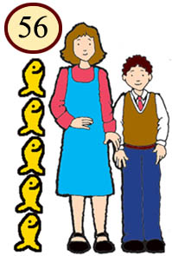
Part A: Using this information, can you tell if a single goldfish is more or less than an inch high?

_____________________________________

Part B: Use what you know about equivalent units of measurement and number operations to explain why your answer is correct. Use words and/or pictures in your explanation.

_______________________________________________________________________

________________________________________________________________________

________________________________________________________________________

________________________________________________________________________

________________________________________________________________________

________________________________________________________________________

