Content Standard: (Gr. 4, 5) 1C.1.a Represent mixed numbers on a number line.
http://www.visualfractions.com/MixedFraction.html

Name__________________________________ Date__________

Maria wants to mark the number line correctly.

Part A: What mixed number belongs where the arrow is pointing?

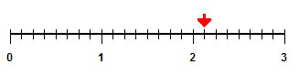
______________________________________________________

Part B: Use what you know about mixed numbers and number lines to explain why your answer is correct. Use words and/or pictures in your explanation.

________________________________________________________________________

________________________________________________________________________

________________________________________________________________________

________________________________________________________________________

________________________________________________________________________

________________________________________________________________________

