Content Standard: (Gr. 4) 6A.2.c; (Gr. 5) 6A.1.b Read, write, or represent decimals using symbols, words or models

http://www.southbury.enfield.sch.uk/mw/decimals/tenths-hundredths.swf

Name__________________________________ Date__________

Luke made a number line with decimals.

Part A: The arrow is pointing to what decimal?

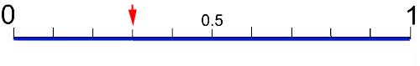
_____________________________________________________

Part B: Use what you know about decimals to explain why your answer is correct. Use words and/or pictures in your explanation.

________________________________________________________________________

________________________________________________________________________

________________________________________________________________________

________________________________________________________________________

________________________________________________________________________

________________________________________________________________________

