Content Standard: (Gr. 4, 5) 1C.1.b Identify positions on a coordinate plane.
http://www.shodor.org/interactivate/activities/pcoords/index.html

Name__________________________________ Date__________

Michael drew a school bus on the coordinate grid.

Part A: What is the position of the school bus on his coordinate grid?

__________________________________________________

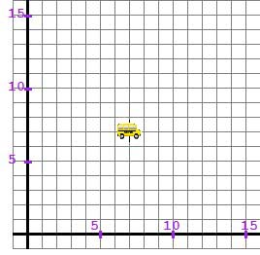

Part B: Use what you know about coordinate grids to explain why your answer is correct. Use words and/or pictures in your explanation.

________________________________________________________________________

________________________________________________________________________

________________________________________________________________________

________________________________________________________________________

________________________________________________________________________

________________________________________________________________________

