Content Standard: (Gr. 3, 4) 2D.1.a Identify or describe geometric figures as congruent.

http://matti.usu.edu/nlvm/nav/frames_asid_165_g_3_t_3.html

Name__________________________________ Date__________

Lucy is learning about congruent triangles.

Part A: Which triangles below are congruent?

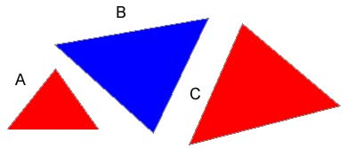

_____________________________________________________

Part B: Use what you know about congruency to explain why your answer is correct. Use words and/or pictures in your explanation.

________________________________________________________________________

________________________________________________________________________

________________________________________________________________________

________________________________________________________________________

________________________________________________________________________

________________________________________________________________________

