Content Standard: (Gr. 3, 4, 5) 3B.1. Measure in customary and metric units
http://www.teachingmeasures.co.uk/length/dragdist/ruler30cm.html

Name__________________________________ Date__________

Kevin and Brianna measured their pencils. Both said that their pencils measured 15 centimeters but one of them was not correct.

Part A: Who did not measure the pencil correctly?
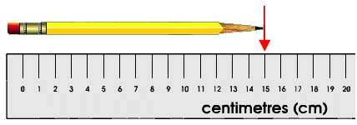

Kevin’s pencil

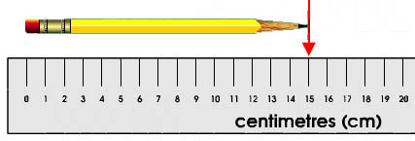

Brianna’s pencil
_________________________________________________

Part B: Use what you know about measurement to explain why your answer is correct. Use words and/or pictures in your explanation.
_______________________________________________________________________

________________________________________________________________________

________________________________________________________________________

________________________________________________________________________

________________________________________________________________________

