Content Standard: (Gr. 5) 3C.1.b Determine area. 7.0 Processes of Math

http://www.shodor.org/interactivate/activities/perm/index.html

Name__________________________________ Date__________

Mr. and Mrs. Williams are replacing their kitchen floor with new tiles. The cost of each tile is $3.50 a square foot. The shaded area in the shape below will get new tiles.

Part A: How much will the new floor cost?

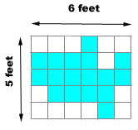

_______________________________________

Part B: Use what you know about area and number operations to explain why your answer is correct. Use words and/or pictures in your explanation.

________________________________________________________________________

________________________________________________________________________

________________________________________________________________________

________________________________________________________________________

________________________________________________________________________

________________________________________________________________________

