Content Standard: (Gr. 1, 2) 4.B.1.c Interpret data contained in single bar graphs.
http://ambleweb.digitalbrain.com/ambleweb/ambleweb/ambleweb/mentalmaths/grapher.html

Name__________________________________ Date__________

Students come to school in different ways.

Part A: How many more students ride the bus to school than walk to school?
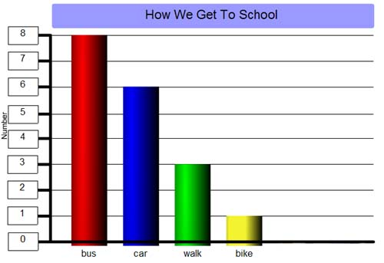
_________________________________________________

Part B: Use what you know about graphs and number operations to explain why your answer is correct. Use words and/or pictures in your explanation.

- - - - - - - - - - - - - - - - - - - - - - - - - - - - - - - - - - - - - - - - - - - - - - - - - - - - - - - - - - - - - -
________________________________________________________________________

- - - - - - - - - - - - - - - - - - - - - - - - - - - - - - - - - - - - - - - - - - - - - - - - - - - - - - - - - - - - - -
________________________________________________________________________

