A global classroom for you? 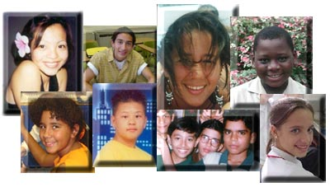
1. Could your students come to deeper understandings and have new perspectives if you invited students from another part of the world to join them in your unit via technology? What results are you looking for?
2. After you find a partner class, and you know what you want your students to gain from this global connection, how will you know that they "got it"? Will your students collaborate with a student from another city/state/country to:
* research a topic and conduct interviews in both locations?
* create some artifact together.... text, art, video, music?
* conduct an experiment in both locations and discuss results?
* take surveys and compare results from both locations?
* compare and contrast some topic or issue as viewed in both locations?
* what else...? [List your ideas here….]

3. Now the challenging part.... what do you need to do to help your students get to (2) and (1) above?
* You need to find the partners. Patti will help! ☺
* You will need to discuss time lines and the expected frequency of interaction.
* Teachers on both ends must understand the goal and agree to work toward it.
* Students on both ends must know the target you are trying to "hit."
* Since collaboration is part of the strategy, all involved must know their roles on the team.
* You will need to design activities, essential questions, and discussions that lead to the desired outcomes.
* KidSpace can be a place to meet and publish student work. Teachers and students will need to learn how to use it. Patti will help! ☺
* What else…? [List your ideas here…]

